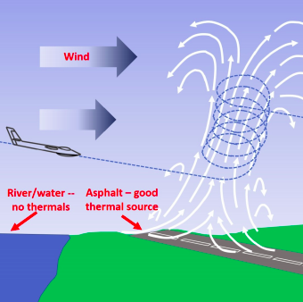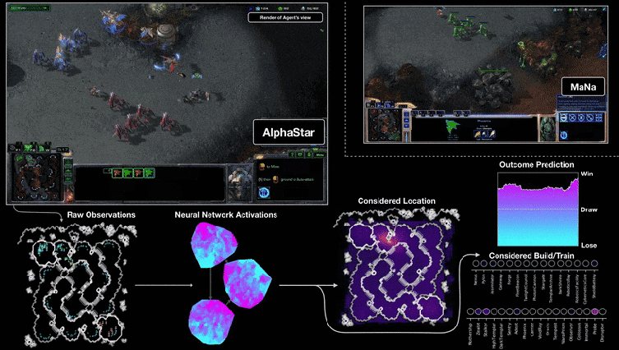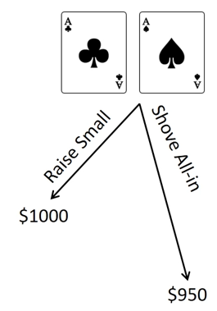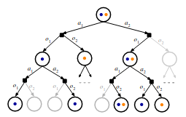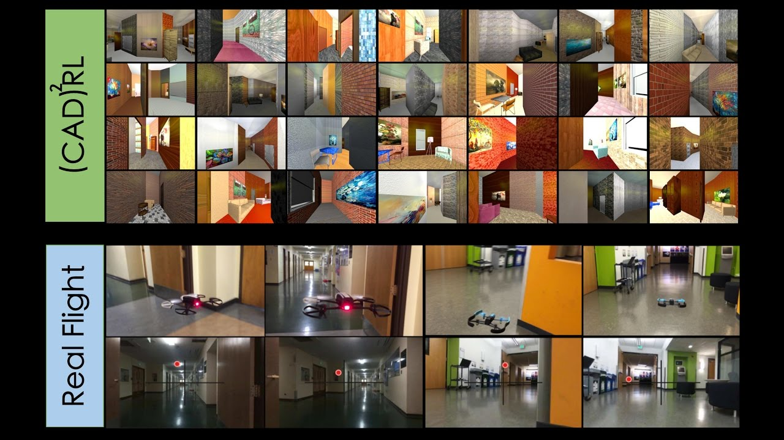ASEN 6519-001 Fall 2021

**Advanced Survey of Sequential Decision Making**

TTh 10-11:15am AERO N250

Instructor: Zachary Sunberg ([zachary.sunberg@colorad](mailto:zachary.sunberg@colorado.edu)o.edu)

This course will provide an overview of important foundational results and new frontiers in sequential decision making under various types of uncertainty, specifically in Markov decision processes (MDPs), partially observable Markov decision processes (POMDPs), and games. Topics will include large scale Reinforcement Learning (e.g. AlphaStar), online and offline POMDP solution methods, theoretical results and tools, alternative problem formulations, and applications, along with additional topics that students show interest in. The primary mode of learning will be through reading research papers and presenting them to the class with discussion. This will be suplemented by guest lectures and traditional lectures that explain background material.

Many of the papers will be drawn from similar courses at other universities, for example: Stanford University’s [CS332](http://cs332.stanford.edu/" \l "!syllabus.md) and [AA229](https://docs.google.com/spreadsheets/d/1naJ7-WajtNyvk_FlduUkLTW32K7PXazlGOMlFjLEUzw/edit" \l "gid=0).

**Assignments:**

* Presentations to the class about important or recent research papers in the field with pseudocode implementation writeup
* 2 Quizzes testing high-level understanding of the papers from class
* Final project (report and presentation)

**Prerequisites:**

* ASEN 5519: Decision Making under Uncertainty (DMU), research experience in robotics or artificial intelligence, or permission from the instructor